LAB 6
HEMACHANDAR P
255HSBD010

1.The echo command can be used simply to display a piece of text (useful in programs).Use echo to create a sentence. Pipe the output of this command to count the number of words in the sentence. How do I use the wc to count the number of lines in this sentence?
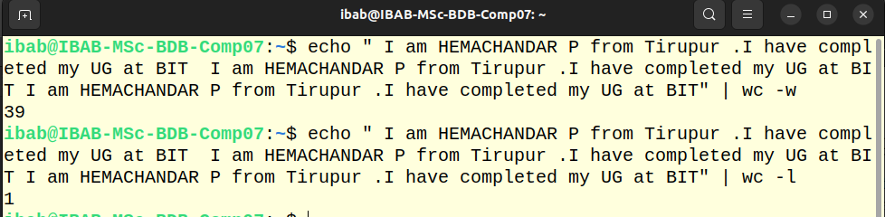

2.Execute the following command, and explain the meaning of the output. This concerns the appearance of the command prompt, and you should be able to dissect the output completely and explain it part by part. Make a list of the parts of the output and write your explanations against each part. The command is cat .bashrc | grep ’PS1’

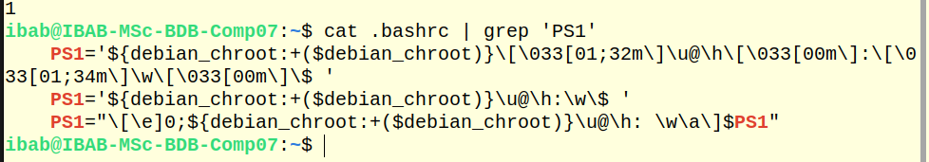
\u – username -IBAB
\h – hostname – IBAB-MSC-BDB-Comp07
\w current working directory
\033[00m\]-Sets color for the working directory path and then resets color

3.In the above exercise, filter the output based on ’HIST’ pattern. You will see a list of environment variables. Figure out what they stand for and what the current values mean.
The grep 'HIST' command in my .bashrc showed:

HISTSIZE=1000
HISTFILESIZE=2000

HISTSIZE sets how many commands are kept in memory for the current session (1000 commands).

HISTFILESIZE sets how many commands are saved to the .bash_history file across sessions (2000 commands). These variables control how much of my command history is saved and retrievable.
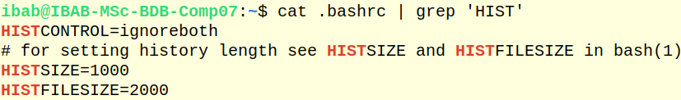
(4) The whereis command searches for a program in a predefined set of standard binary directories such as /bin, /usr/bin and /usr/sbin. Type whereis ls and study the output. What is the difference between which and whereis commands?

which returns the pathnames of the files (or links)
whereis - locate the binary, source, and manual page files for a command
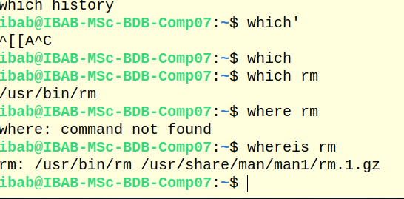

5.The command dirname is used to retrieve the directory name in a given file path. Navigate to a previous lab folder such as Lab4 and list the files. Then type the command dirname <filename> where give some existing filename in this command. What is the output?
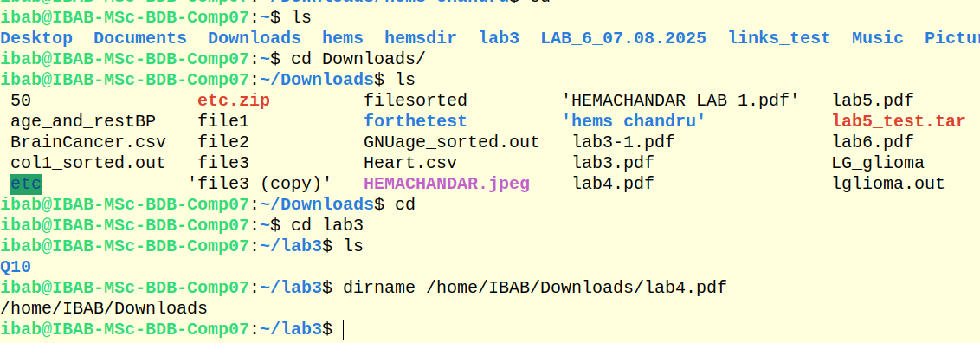

6.Create a local variable called mylabdir, and set it to the following value: /home/ibab/Lab6 (which means that if you have not created a Lab6 folder you should do so). Print the value of this variable using the echo command, and then the dirname command output with a file you are working with, under the Lab6 directory.
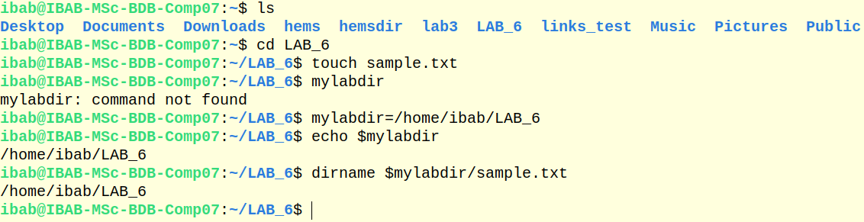

7.Create a new bash subshell in this terminal. Prove that you have created a subshell using the ps command with the appropriate options. Inside this subshell print the value of the variable mylabdir. What is the value? If it is empty, how do you convert it to a global variable? Do the conversion and show that mylabdir is indeed a global variable
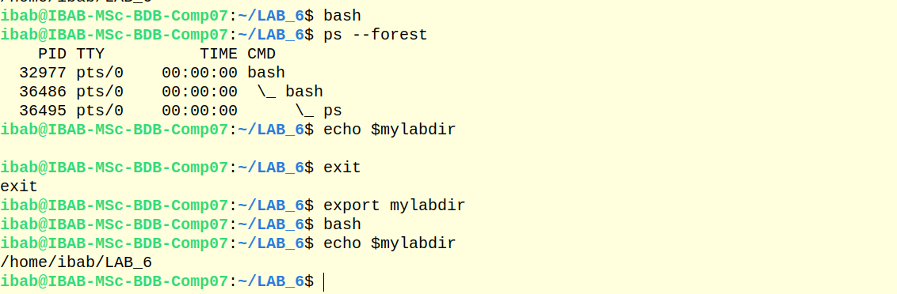
(8) Display the output of the command echo $PATH. Is PATH local or global variable? Describe two ways of finding this out.

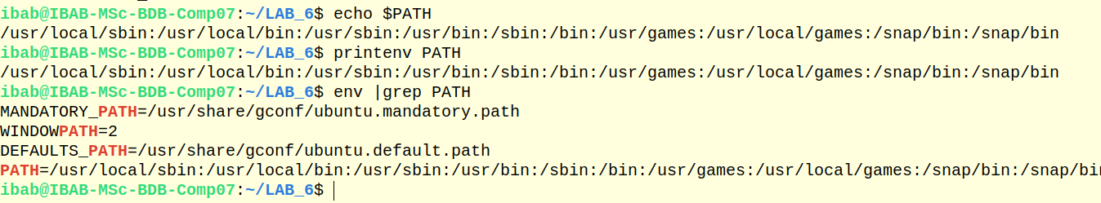
PATH is a global variable
For printenv PATH
It is showing a value , thats why it is global variable

For env |grep PATH
env shows only the global variable and using grep env it is narrowed down that PATH is global variable

(9)The concept of a directory stack. Learning about this will allow you to know the powerful navigation mechanisms in Linux. The key commands in this exercise are dirs,cd -,pushd and popd. The directory stack operates like a stack of plates – the last plate on top is the first to be taken out. Try the following exercises to understand this.
(i) Execute dirs -v -l. What is the output? Learn more about the command
and the options by looking up the man pages of what these options did. For
each command below execute dirs -v -l to understand what happened to the
directory stack.

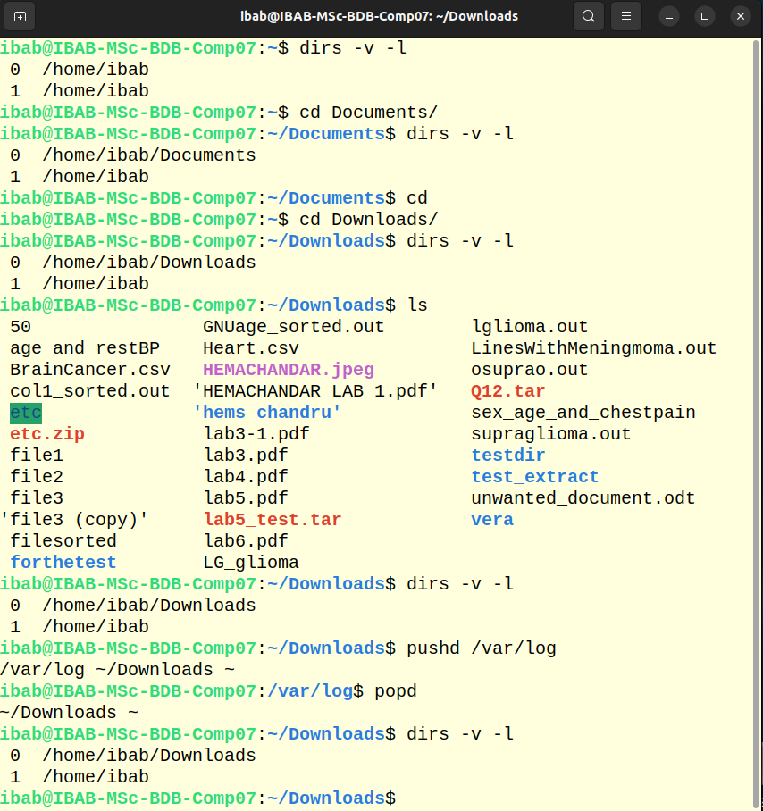
ii)By default the directory stack contains only one entry – the path to your $HOME.
Let’s add some entries to this stack using the following commands:
(a) pushd /var/log
(b) pushd /tmp
(c) pushd /etc
(d) pushd ~/Downloads
(e) pushd ~/Documents

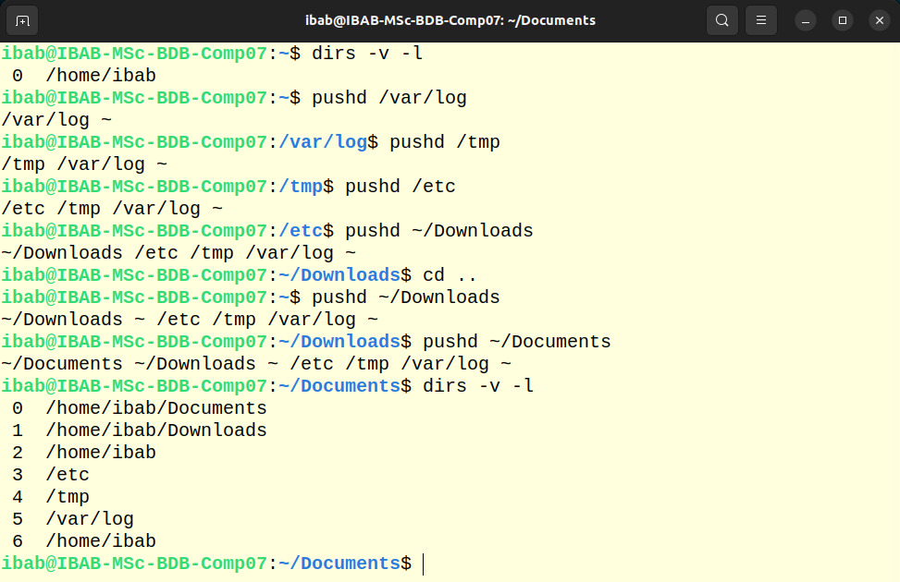

iii)Now execute dirs -v -l again. Explain the output.
1. pushd /var/log - Adds current directory to stack and changes to /var/log.
2. pushd /tmp - Adds /var/log to stack and changes to /tmp.
3. pushd /etc - Adds /tmp to stack and changes to /etc.
4. pushd ~/Downloads - Adds /etc to stack and changes to ~/Downloads.
5. cd .. - Changes to parent directory of ~/Downloads.
6. pushd ~/Downloads - Adds current directory to stack and changes to ~/Downloads again.
7. pushd ~/Documents - Adds ~/Downloads to stack and changes to ~/Documents.
(iv) Execute the command pushd +1. Explain what happened.
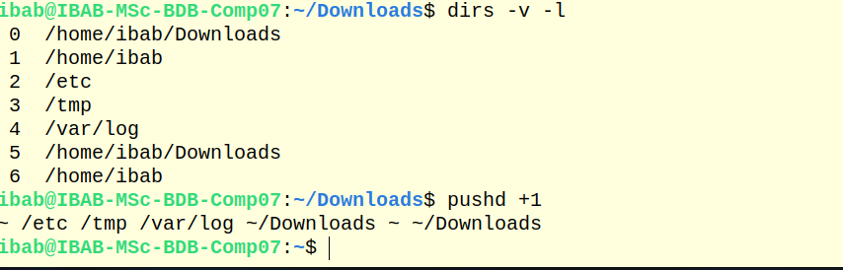
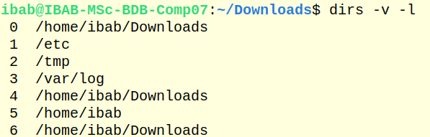
In the above after giving the command it enters from downloads to the etc

v)Execute cd -. What happened?

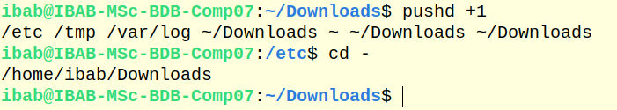

vi)Execute cd /tmp. What happened? In this case, note that we simply changed directory to an entry in the directory stack without reference to the stack in anyway.
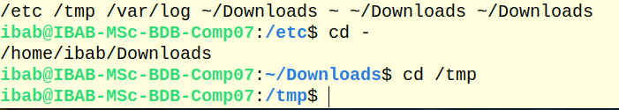

vii)Execute popd. What happened? popd is responsible for removing the topmost “plate” in the stack and changes to the directory entry against index 1.
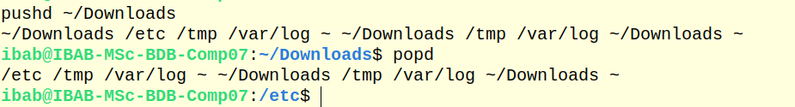
viii)Execute popd +2. What happened? How is this different from pushd +2?
popd +2 removes the directory at position 2 from the stack.

(ix) In all the above, what was happening the entry that was indexed against ’0’?Explain what this entry represents.

- dirs entry at index 0 represents the current working directory.
- pushd adds the current directory to the stack and changes to a new directory.
- popd removes the top directory from the stack and changes to the new top directory.

